

Pirates Trading Post

Version 3



October 21, 2019

Thomas J. Short

Cis 260-01

**Pirates Trading Post Documentation**

**Requirements:**

In this version we are required to supply the pirates with an item code and let the pirates choose the items they want to purchase. Then, we are required to show the pirates what they ordered and how much money the total purchase will cost them in bits. After that, we are required to ask the pirates how much they are paying with, then calculate and display their change, as we did before in version 1 and version 2. Also, in version 3 the pirates have asked us to print their change with better formatting.

**Analysis:**

**What is the Problem?**

The pirates want a way to order specific items based on a specific item code and receive a receipt showing them the items they are going to purchase. To do this must also keep track of how many items the pirates purchased and the cost of each item. We must formulate a calculation to count each individual item and then give us a total number for each of the items. We must display them a nicely formatted receipt and continue with Version 2 as before, while formatting the change better.

**How will we know if we solved the problem?**

We know we solved the problem correctly if the program Shows the pirates what they have ordered, how many of each item they ordered, adds the cost of the items they ordered together correctly, prints the total back to the user and then continues with our program as before in version 2. We also need to look for better printing format so the string must line up nicely.

**TEST SET: Pirate Version 3**

|  |  |  |  |
| --- | --- | --- | --- |
| INPUT | EXPECTED OUTPUT | OUTPUT | RATIONALE |
| ?, enter | Show user the valid item codes and allow more input | Valid item codes are: 8 I H M S T  Q to Quit  Enter the item code or press ? or Q | This will show us if the? is assigned correctly. |
| Q, enter  1, enter | Exit and calculate,  Get back my whole doubloon | Your receipt consists of:  1 doubloon | This will show us if q is assigned correctly. Since there is no purchase, we get our full amount back. |
| I, enter  H, enter  88TT, Q, enter  3, enter | 1 eye patch  1 pirate hat  2 pieces of eight  2 Tee Shirts  Total bits 350 | Your receipt consits of:  2 Pieces of eight  1 Pirate Hat  1 Eye patch  2 Tee Shirts  Your total cost is 350 bits | Tests single line entry’s and multiple item codes on the same input line, Also, show us plurals and single grammar |
| 8, h, I, S, M, T, K, 1, enter  Q, enter | 1 piece of eight  1 hat  1 eye patch  1 sword  1 map  1 tee shirt  Total bits 312 | Your receipt consits of:  1 Piece of Eight  1 Pirate Hat  1 Eye patch  1 Inflatable Sword  1 Treasure map  1 Tee Shirt  Your total cost is 312 bits | Tests ever valid code left, k and 1 will show us invalid message and let us try again but still adding the rest. Q will exit and calculate result |
| <=, enter  Whitespace , Qq | Invalid characters | Invalid warnings | Just wanted to try a few more invalid characters to see if the program would break or not |

**Pirate Trading Post Version 3**

**Algorithm**

Import java scanner

Create a public class for the pirates trading post

Open a main method

Initialize a variable for user Input

Declare variables to keep track of the number of items purchased assign them the value 0

Declare variables to keep track of the cost of the items we are counting and assign them the appropriate values

Create a new scanner object

Display a welcome message

Create a while loop with a sentinel value to end the loop

Prompt user to enter an item code, press ? to see item list or Q to exit and calculate

Get input and assign it to the user’s string

Covert the user input to lowercase for less user mistakes

Check the user string at each character and add letter to the counter

Check to see if the user entered a ? if the did display the valid item codes and ask the user if they want to calculate

Check if the user character is anything other then what we are supposed to enter

Display the items back to the user with a total cost of the items purchased using plurals or singles

Declare an integer variable to hold the total price of their order

Calculate using the number of each item multiplied by the cost of each item while adding those values together

Display the total price of their purchase

Continue with the code from version 2

**Pirates Trading Post Results test1 and test2 and test3: Version 3**

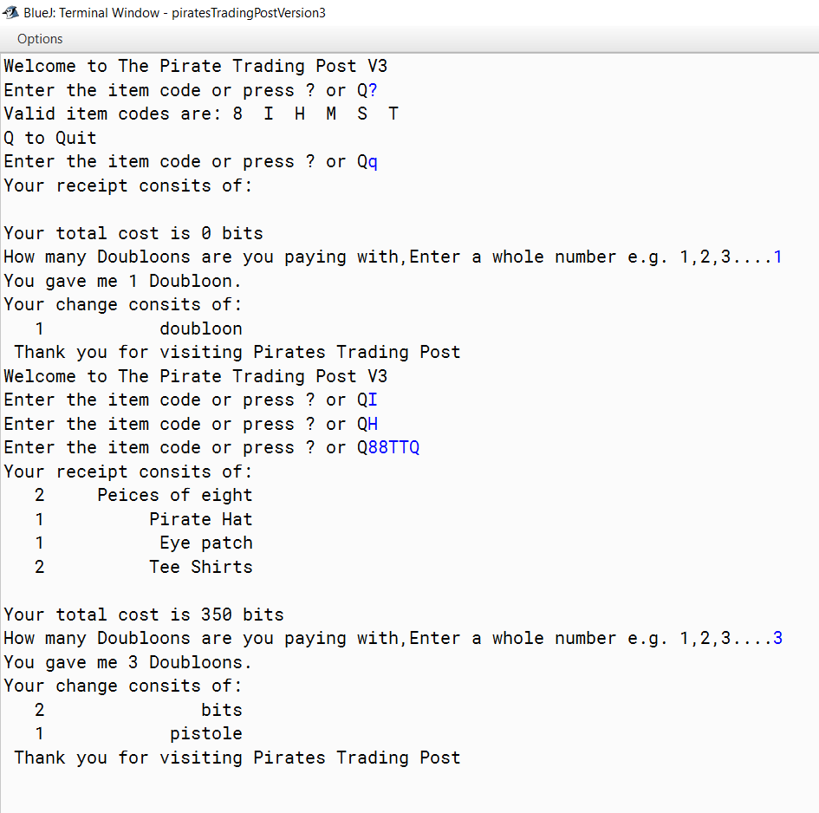

**Pirates Trading Post Results Test 4: Version 3**

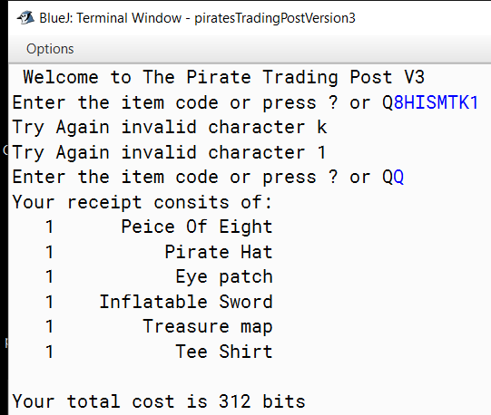

**Pirates Trading Post Results Test 5: Version 3**

